2016 Summit Trek

  - [Camp Name]

Program Fact Sheet

Fees

$[Cost] per person
If paid in full by [date]
$[amount] deposit per group due upon registration
Fee includes transportation, 11 meals, tents, cots, Wi-Fi and all program equipment.

Eligibility

For registered Boy Scouts, Varsity Scouts, Venturers age 13 & up and registered Adult Leaders
-Must be between 50 and 250 lbs to participate in Aerial Sports activities (climbing, zip-lines, etc)
-Must pass BSA swimmer test for all aquatic activities

Available Dates

June 20 – June 24
June 27 – July 1
July 4 – July 8
July 11 – July 15
July 18 – July 22
[Camp Name] is proud to offer the Summit Trek: an opportunity for Scouts and Venturers to enjoy the adventures available at the Summit Bechtel Reserve, the BSA’s newest national base in West Virginia! This exclusive opportunity includes meals, roundtrip transportation, and the programs available in the Walter Scott Summit Center. Participants will head to The Summit Monday morning and head back to camp on Friday morning, allowing them to travel and experience opening/closing program with their home unit.

Open Program Opportunities

Action Point
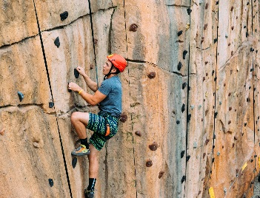
- Challenge Course
- Canopy Tours
- BMX Race Tracks
- Skate Park
- Harvey Mountain Bike Trails
- CONSOL Energy Bridge

Shooting Sports Annex
- Static Archery
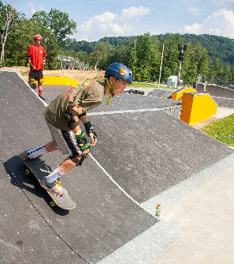
- Sporting Arrows
- Rifle Shooting
- Tomahawk Throw

Goodrich Lake
- Kayaking
- Paddleboarding
- Fishing
- Water Obstacle Course
- Gottschalk Boardwalk

Boulder Cove
- Climbing
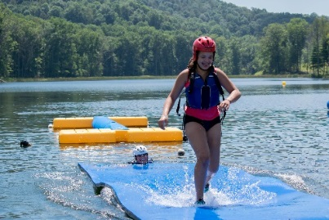
- Rappelling
- Bouldering

Gateway Village
- Summit Center Zip Lines
- 37°N Outfitters
- Sustainability Treehouse

 | Sunday | Monday | Tuesday |  | Wednesday | Thursday |  | Friday | Saturday
AM |  |  |  | The Summit  4 Days (4 nights)
PM | Local  Camp |  |  |  |  |  | Local  Camp
Eve
Event open during evening activity period only

Have Questions?

Please Contact Us!
XXX-XXX-XXX
[Camp/Council Name]
[Camp Address]
[contact]@scouting.org
www.[camp/council site].org

Summit Trek Schedule

Day 1
12-3pm Arrival
1:00pm Venues Open
4:30pm Venues Close
4:45pm Flag Lowering
5:00pm Dinner
5:30pm Venues Open
8:00pm Venues Close
8:30pm Flag Retirement Ceremony
10:00pm Taps

Day 2
7:30am Flag Raising
8:00am Breakfast
9:00am Venues Open
4:30pm Venues Close
4:45pm Flag Lowering
5:00pm Dinner
5:30pm Venues Open
8:00pm Venues Close
7:30pm International Campfire & Social
10:00pm Taps

Day 3
7:30am Flag Raising
8:00am Breakfast
9:00am Venues Open
4:30pm Venues Close
4:45pm Flag Lowering
5:00pm Dinner
5:30pm Venues Open
8:00pm Venues Close
7:30pm Evening Program
10:00pm Taps

Day 4
7:00am Breakfast
8:00am Whitewater Rafting
12-2pm Return
4:30pm Venues Close
4:45pm Flag Lowering
5:00pm Dinner
5:30pm Venues Open
8:00pm Venues Close
7:30pm Appalachian Celebrachian!
10:00pm Taps

Day 5
7:30am Flag Raising
8:00am Breakfast
9:00am Departure

